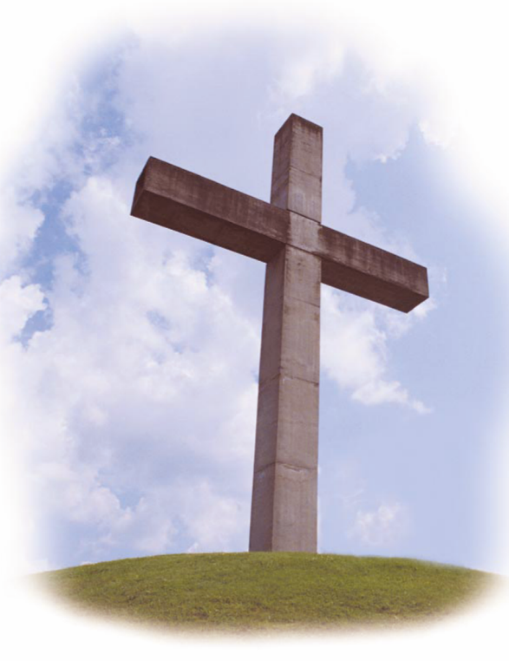
Looking for a way to include God in your marriage? You’ll discover how to do just that on a Worldwide Marriage Encounter Weekend!
Good marriages DESERVE a Marriage Encounter Weekend.
(302) 529-9261 or (866) 633-3862
…or visit us at www.encounter.org

2014 Weekends:

Feb. 21-23 Havre de Grace, MD Vandiver Inn
(Coordinated by the Presbyterian Expression of M.E.)
Mar. 21-23 Winchester, VA Lee-Jackson Inn
Nov. TBD Easton, MD Comfort Inn

