

Worldwide
Marriage Encounter

Languages
Of
Love

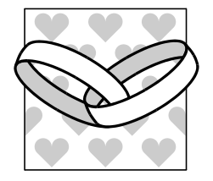


Partially taken from The Five Love Languages by Dr. Gary Chapman, Moody Press, Copyright 1992.
Used with Permission
Images of Languages of Love

Different “ Languages”
- Different “Dialects”
- Emotional “Love Tank”


NOTES

1

2

3

4

5

Love Tank

How full is my love tank right now?


Dialogue/Sharing

Dialogue:
What are my feelings as we begin this enrichment?

Sharing:

Share how you felt when your love tank was FULL during your dating days.

What did MY spouse do that helped me feel loved?
Falling in Love

Indicators:

Not act of will

- Effortless and instinctive, requiring little discipline

- Lack of genuine interest in spouse’s personal growth

- Notes:


Being in Love =

Decision to Love

Indicators:
- Emotional but not obsessive

- Requires an act of will, effort and discipline

- Based on reason

Seeks growth for the spouse

- Notes:

Exercise
List a few crazy things that we did when we were falling in love:

1. ________________________________
__________________________________
2. ________________________________
__________________________________
3. ________________________________
__________________________________

Dialogue:
Recall a time of being in love (Deciding to love) WAMFAT?

Sharing:
Share a recent experience of deciding to love my spouse. What makes it difficult for me to love in this way?
SHARING SALT
- Be Sensitive to each person’s different pace

- Allow opportunities for everyone to contribute

- Listen with your hearts and minds to those in your group

- Try to move along through questions, different people will respond in different ways
The 5
Love Languages

Words of Affirmation
Quality Time
Receiving Gifts
Acts of Service
Physical Touch
Love Language 1
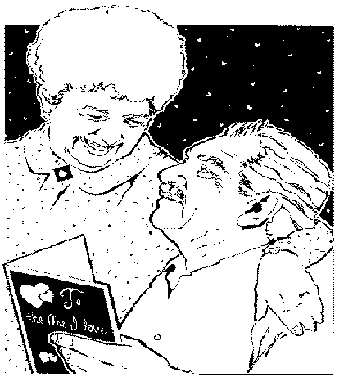

Words of Affirmation
Quality Time
Receiving Gifts
Acts of Service
Physical Touch

Words of Affirmation
Using words that build up

Dialects

Complimentary Words
- You look sharp in that suit.
- Do you ever look nice in that dress. WOW!
- You must be the best cook in the world. I love these potatoes.
- I really appreciate you washing the dishes tonight.
- I really appreciate you taking out the garbage.

Encouraging Words
- You’re the best engineer for that job. You can do it!
- If you want to be an artist, you should try it! You are really good.

Kind Words
- I understand why you forgot to stop at the store. Don’t worry about it, we can go together.
- It’s okay if my new suit isn’t pressed. I can wear the other one to the meeting.
- Request Words
- I love those apple pies you make, would it be possible for you to make one for me this week?
- I would like to spend some time with you. Could we go to a movie tonight?

- Words of Praise
- You are a wonderful father.
- You have a wonderful way of working with people. You sure do help everyone to be a part of the group.

- Words of Thanks
- Thank you for taking that phone call for me, I wasn’t really up to it.
- Thanks for being home on time, it helped me to feel more relaxed about being ready to leave on time.

Exercise
LIST SOME OF YOUR SPOUSE’S POSITIVE TRAITS:
1__________________________________________________
2__________________________________________________
3__________________________________________________
4__________________________________________________
5__________________________________________________
6__________________________________________________

Examples:
- He hasn’t missed a day of work in 12 years.
- He makes the house payment every month.
- He mows the lawn every week.
- He carries out the garbage every week without me asking.
- She makes the beds every day.
- She is a very neat housekeeper.
- She is a great cook.
- She does the washing and most of the ironing.
Exercise
- Read what your spouse wrote.

- Express verbal appreciation to your spouse for one or two things on your list

- Write down two things that helped you feel loved, because your spouse has affirmed you about them verbally.

1___________________________________________________

2___________________________________________________

Dialogue:
HDIF when you use words of affirmation towards me?

Commitment:
At least once per week, verbally affirm your spouse for a quality or something they do.
Love Language 2
- Words of Affirmation
Quality Time
Receiving Gifts
Acts of Service
Physical Touch
Quality Time
- Togetherness
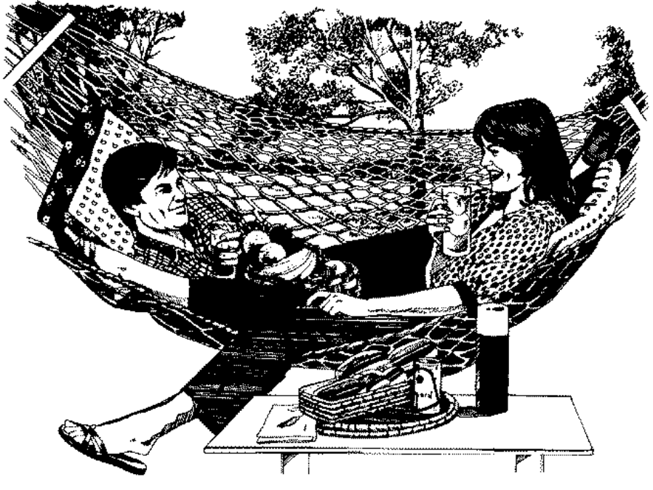
- Focused and Undivided Attention

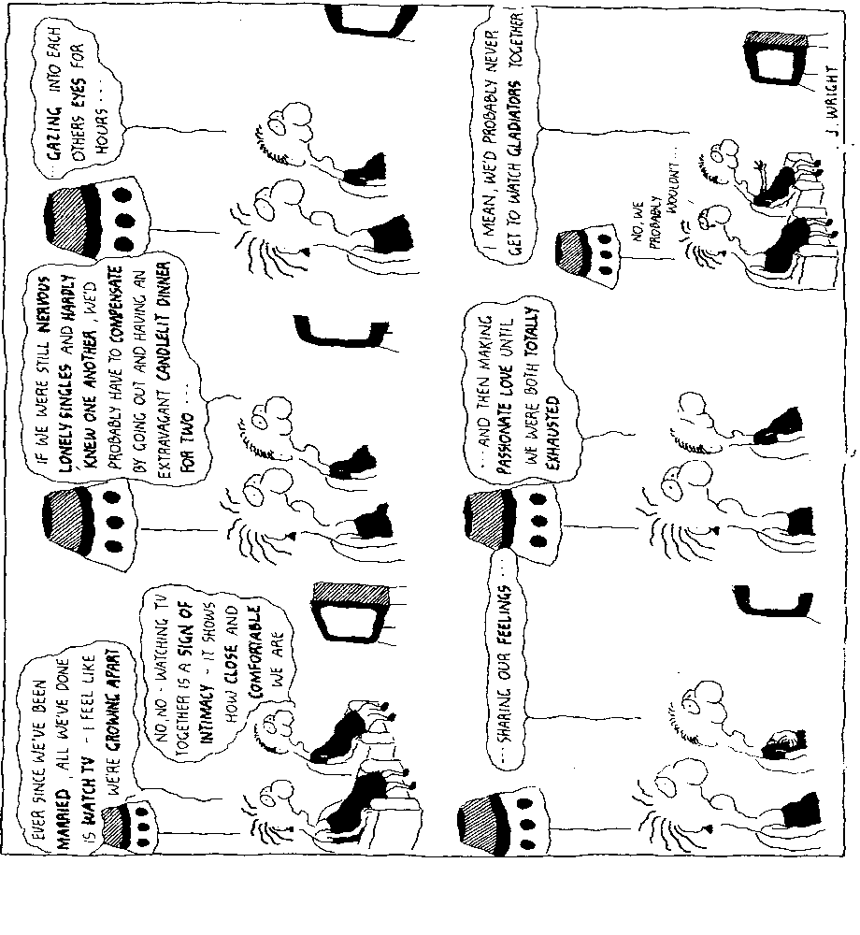
Quality Time
Dialects
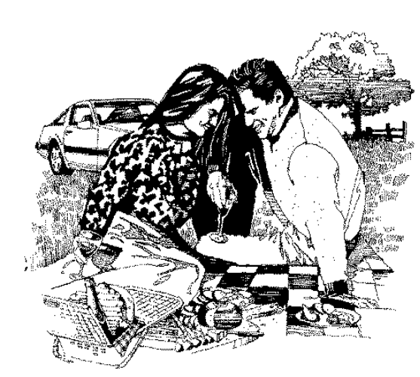
- Quality Conversation
- Quality Activities

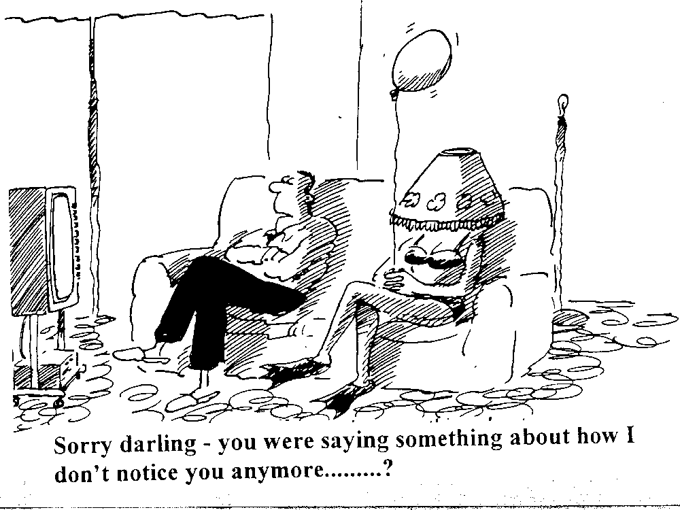Quality Conversations

Quality Conversations
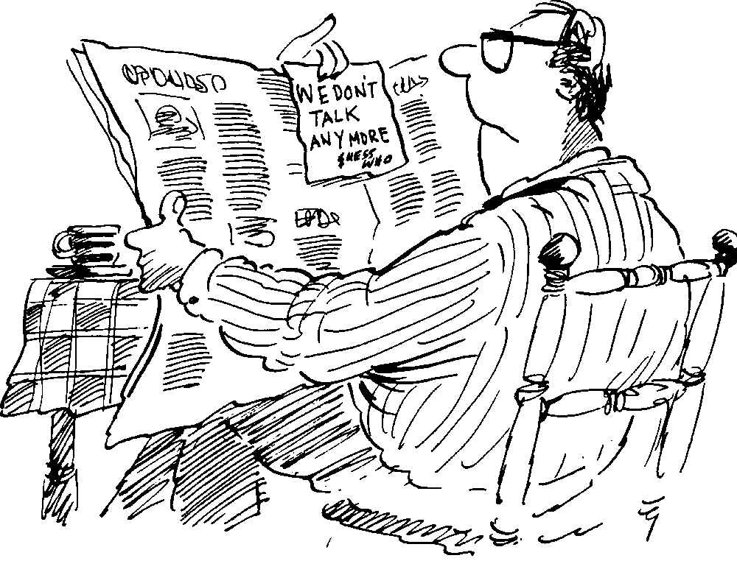
Quality Time
Learning to Talk:
List 3 things that happened to you yesterday or today and what was the feeling that you had at the time:
- 1. __________________________
- Feeling: _____________________
- 2. __________________________
- Feeling: _____________________
- 3. __________________________
- Feeling: _____________________
Exercise
Make two lists:
- List activities that I would like my spouse to do with me
  - ________________________________________
  - ________________________________________
  - ________________________________________
  - ________________________________________
  - ________________________________________

- List activities that I think my spouse would like me to do with him/her
  - ________________________________________
  - ________________________________________
  - ________________________________________
  - ________________________________________
  - ________________________________________

- Quietly share with your spouse what you wrote
Sharing Question:
What new thing did I learn in this presentation and exercise?

Commitment:
At least once per month do an activity that your spouse would like you to do with them. This is a choice by you, not a requirement from your spouse.

Love Language 3

- Words of Affirmation
- Quality Time
Receiving Gifts
Acts of Service
Physical Touch

Love Language 3
Receiving Gifts

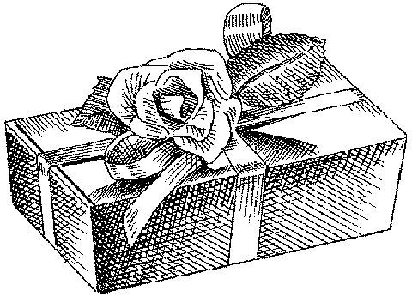
- Visible Symbol of Love

Exercise:
Make a list of all the gifts your spouse has expressed excitement about receiving through the years. These can be gifts from you or from others.

1__________________________________________________
2__________________________________________________
3__________________________________________________
4__________________________________________________

List at least 2 gifts that your spouse gave you that helped you feel loved and special:

1_________________________________________________
2_________________________________________________

You may wish to look at the gift as an

Inve$tment

In the Relationship


The value of the gift
Is in the eye of the
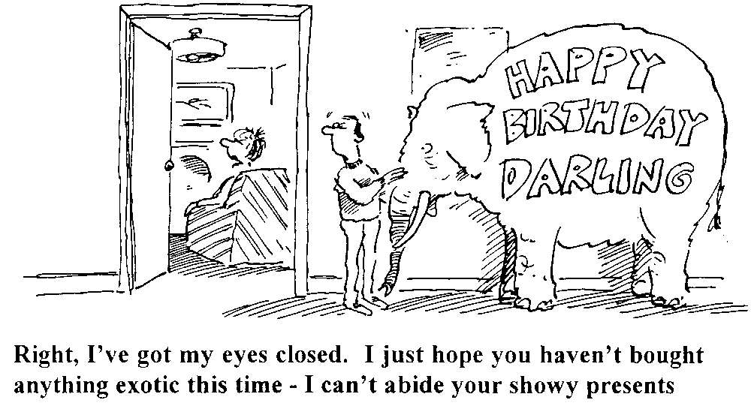Beholder

Sharing:
How important is giving/receiving gifts to me in expressing or experiencing love?

Remember: We are talking about all kinds of gifts here, not just gifts that are expensive, or even purchased. The bouquet of wild flowers is a gift of love.

Commitment:
At least once per week, surprise your spouse with a gift of love. Remember that it can be a simple flower or a night out to dinner, but it needs to be something you give in order to lift up your spouse with love.
Love Language 4
- Words of Affirmation
- Quality Time
- Receiving Gifts
Acts of Service
Physical Touch
Love Language 4
Acts of Service

Doing Things:
With thought, effort and with a positive spirit



Acts of Service

Dialects:

- Requests not Demands
- Special Projects vs. Routine Tasks
- Important to Spouse as a Person
- Unexpected/ Surprise Acts
Impediments to
Acts of Service

What we do for each other before marriage is no indication of what we will do after marriage.

Love is a choice and cannot be coerced.

Requests give direction to love, demands stop the flow of love.

Making demands can be seen as treating our spouse as an object.

Criticisms and demands can dry up our love tanks.

The criticism from your spouse can be a clear clue as to their primary love language.

Learning the love language of acts of service will require some of us to reexamine our stereotypes of the roles of husbands and wives.
Exercise
List 4 things that would help you feel loved if your spouse did them for you (REMEMBER: these are requests, not demands. You have no right to EXPECT your spouse to do them)

Now list 4 things that you think would help your spouse feel loved if you did them for him/her:
1______________________________________________
2______________________________________________
3______________________________________________
4______________________________________________
Dialogue: Recall an act of service from my spouse or when I tried to love via an act of service. WAMF recalling this?

Sharing: How important is this love language to me? Name a time when my spouse surprised me with an act of service.

Commitment: At least once per week, surprise your spouse with an act of service that he/she would not expect.
Love Language 5
- Words of Affirmation
- Quality Time
- Receiving Gifts
- Acts of Service
Physical Touch
Love Language 5
Physical Touch
- To touch my body is to touch me

- A powerful communicator of emotion


Physical Touch
Dialects:

- Touch as Communication
- Sexual Touch/ Intercourse
- Touch in Crisis
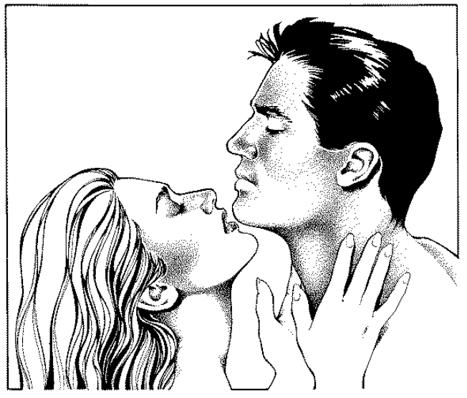
Physical Touch
Physical touch, as a gesture of love, can reach to the depths of our being and really help fill our emotional love tanks.

Of the five senses, touching, unlike the other four, is not limited to one localized area of the body. It causes pain or pleasure. We interpret the touch as hot or cold, loving or hostile.

Physical touch can make or break a relationship. It can communicate hate or love.

LUKE 8:43 – 48

43And a woman was there who had been subject to bleeding for twelve years,D but no one could heal her. 44She came up behind him and touched the edge of his cloak, and immediately her bleeding stopped.
45"Who touched me?" Jesus asked. When they all denied it, Peter said, "Master, the people are crowding and pressing against you." 46But Jesus said, "Someone touched me; I know that power has gone out from me." 47Then the woman, seeing that she could not go unnoticed, came trembling and fell at his feet. In the presence of all the people, she told why she had touched him and how she had been instantly healed. 48Then he said to her, "Daughter, your faith has healed you. Go in peace."

Jesus used touch as a message of His love for His people. Loving touches are a basic of love, no matter what your primary language.

Some common expressions of physical touch:

- Holding hands
- Pinch your cheeks
- Kisses and hugs
- Snuggling in each other’s arms
- Sexual intercourse

Aspects of physical touch:
- Think of touch as having a broad spectrum.
- We all thrive on touch
- Sexual intercourse is only one dialect
- Don’t forget, our priests and religious can have the love language of physical touch!

Physical Touch
Touches are not created equal.
- Even the same touch can be received differently on different occasions.

- Some touches will bring more pleasure than others.

- Touches may be simple and only require a moment such as a pat on the back or helping someone get out of the car.

- Touches may be explicit and require your full attention

- Be considerate and aware of how we touch, what pleases our spouse and what does not, what is appropriate and what is not.

- What is most important is for the touchee to feel free to give feedback on whether a touch is pleasurable or not.

- Don’t make the mistake of thinking that the touch that brings pleasure to you will also bring pleasure to your spouse!

Almost instinctively, in times of crisis, humans hug or physically reach out to one another. It is at these times that our greatest need is to seek the reassurance of love.”
“The body is for touching. Whatever there is of me resides in my body. To touch my body is to touch me.

- Touching sends messages of love, warmth, caring.
- Touches reach into our emotions.
- Touches talk and express feelings beyond words.

“To withdraw from my body is to distance yourself from me emotionally.”
- Pulling away from touches can cause a range of feelings from concern to deep pain and loss.

- Feelings can be of inadequacies and loss.

- Feel disaffirmed with lack of touches.

Below is a list of examples of physical touches. We would like you to use a rating scale of 1 to 5, where 1 is not at all pleasurable, and 5 is highly pleasurable. On the left side of the page marked “your spouse” is a box to write in what you believe your spouse would rate this touch. For example: do they like you playing with their hair? On the right side marked “your rating” put in your rating of this physical touch. For example: Do you like it when your spouse plays with your hair?

Your Spouse Physical Touch Description Your Rating

Playing with your hair

Pinching of cheeks

Rubbing ears

Kissing

Hugging

Holding Hands
Kissing on the neck

Back Rubs
Foot massages
Slow dancing
Blowing on the ears
Facial touches
(Other)
(Other)
(Other)

Dialogue
Dialogue:
Share a time when I experienced love from my spouse through physical touch. WAMF recalling this?

Commitment:
At least once per week, take a 1 minute vacation (hold each other close wherever you are at the moment) for 1 whole minute and if you are in an appropriate place, learn how your spouse needs to be touched at the moment. Simple touches on the face or shoulders say a lot!
Discover Your Primary Love Language!
The Hurts
What does my spouse do/fail to do that hurts most deeply?

The Requests
What have I most often requested?

Giving of Love
How do I regularly express love to my spouse?

Others
Look back to early times!
Do a love tank check?

The 5
Love Languages

Words of Affirmation
Quality Time
Receiving Gifts
Acts of Service
Physical Touch
Discover Your Primary Love Language!

Answer the following questions:
What does my spouse do/fail to do that hurts most deeply? The opposite of what hurts you the most is probably your love language.
____________________________________________________________________________________________

What have I most often requested of my spouse? They are likely the things that help you feel most loved!
____________________________________________________________________________________________

In what way do I regularly express love to my spouse? Your method maybe an indication of how you would like to be loved!
__________________________________________________________________________________________________________________________________________

What do I think my primary love language is?
______________________________________________
List the other 4 love languages in the order of preference:

2___________________ 4 _____________________

3___________________ 5 _____________________

Discover Your Primary Love Language!

Now, write down what you think your spouse’s primary love language is:
_____________________________________________

After completing the above questions, discuss what you wrote with your spouse.

Sharing:
What did I discover in this session, about myself and how I need to love my spouse?

Commitment:
Put on your calendar a way to reinforce your desire to love your spouse in his/her love language. Maybe include it in one of your dialogues.
Love Language 6
Dialogue as a Language of Love

Focus on Feelings

Intimacy Grows



Dialogue
Conversion of Heart
- Take responsibility for feelings
- Share them – listen and accept

Conversion of Mind
- Take responsibility for thoughts
- Learn and understand

Conversion of Habit
- Take responsibility for behavior
- Make responsible choices
Dialogue
Dialogue

What has been the impact, on us and on our dialogue, of discovering our love language this weekend? WAMFAT. DILD

Commitment:
Make daily dialogue a decision to love your spouse. Make it a habit to love your spouse each day as part of your dialogue, in their love language, if possible.

Commit to continued growth in intimacy by attending other enrichments. Learn to love each other better so that your Sacrament can be a beautiful Sign of Christ’s love.

Appendix
Prayer
Staying In Love

When we first fell in love, Lord,
our love for each other was so intense, so alive.

We realize, Lord,
that love can’t remain at the same level day in and day out,
but help us at least occasionally recapture
some of those precious feelings and emotions
that we so often experienced
when we were falling in love.

Lord, don’t let either of us ever allow our marriage
to turn into a taken-for-granted relationship.
And when we are tempted to blame our partner
for any dullness that may occasionally exist,
remind us, Lord,
that it is the responsibility of each of us
to continually try to put a little more vitality
and romance into our lives.
It’s up to each one of us to go out of our way
to make the other feel needed, appreciated and special;
to praise each other, compliment each other, and give each other the security of feeling truly loved.
Let us learn, Lord, not only how to rekindle the spark that started our love;
but also how to turn that spark into a flame
that will grow brighter with each passing year.

The prayers used in the Languages of Love Formation were taken from “Prayers for Married Couples” by Renee Bartkowski
ISBN 0-89243-301-9
Prayer

Let Us Learn to Love as You Do

Let us learn to love each other
As totally and completely and unconditionally
As you always love us.
You look at us, Lord,
And see all our faults and weaknesses;
You see our pettiness,
Our selfishness,
Our narrow-mindedness,
Our arrogance,
And still you love us.
You love us just as we are
With all of our flaws
And imperfection
You love us without reservation or condemnation.
Teach us, Lord,
To love exactly as you do.
Prayer
Doing Our Share
Did each of us pull our fair share of the load today, Lord?
Or did we tend to sit back and let our partner
do more than they should have?

Help us, Lord, to always be fair enough and loving enough to willingly help each other with the many chores
that must be done each day.

It’s so easy, Lord,
especially when we feel tired or lazy,
to evade lending each other a helping hand.

It’s so tempting to just hold back and wait
for our partner to do all the
tedious and unpleasant jobs.

Let us realize how selfish and unfair it is
to take advantage of our loved ones in this way.

Teach us, dear Lord, how to be thoughtful and considerate enough
not only to undertake jobs without being asked
but to also do them without complaining.

Love Language Commitments

WORDS of AFFIRMATION:
At least once per week, verbally affirm your spouse for a quality or something they do!

QUALITY TIME:
Once per month do an activity that your spouse would like you to do with them. This is a choice by you, not a requirement from your spouse.

RECEIVING GIFTS:
At least once per month, surprise your spouse with a gift of love. Remember that it can be a simple wild flower or a night out to dinner, but it needs to be something you give in order to lift up your spouse with your love.

ACTS OF SERVICE:
At least once a week, surprise your spouse with an act of service that he/she was not expecting.

PHYSICAL TOUCH:
At least once per week, take a one minute vacation (hold each other close wherever you are at that moment for one whole minute) and if you are in an appropriate place, learn how your spouse needs to be touched at that moment. (Simple touches on the face, hair or shoulders say a lot!)

LOVE YOUR SPOUSE:
Put on the calendar a way to reinforce your desire to love your spouse in his/her love language. Maybe include it in one of your weekly dialogues.

DIALOGUE:
Make daily dialogue a decision to love your spouse. Make it a habit to love your spouse each day as part of your dialogue in their love language, if possible.
Commit to continue growing in intimacy by attending other enrichments. Learn to love each other better so that your Sacrament can be a beautiful Sign of Christ’s love.

LOVE TANK GAME: TANK CHECK
When you come home one of you says to the other, “On a scale of zero to ten how is your love tank tonight?” Zero means empty and ten means I’m full of love and can’t handle any more. You give a reading on your emotional love tank ten to zero indicating how full it is. Your spouse says, what could I do to help fill it. When you make a suggestion (something you would like your spouse to do or say that evening) to the best of their ability they will respond to your request. Then you repeat the process but you exchange roles so that both of you have an opportunity to do a reading on your love tank and make a suggestion towards filling it. If you play the game for three weeks, you will be hooked on it and it can be a playful way of stimulating love expressions in your marriage.
Enrichment Evaluation Form
What is your predominant personality style: Catalyst Organizer Helper Thinker

What do you believe is your love language?___________________________________________________

Are you male or female? Male Female

1. What did you like most about the material presented? ________________________________________
______________________________________________________________________________________

2. What did you like most about how it was presented? _________________________________________
______________________________________________________________________________________

- What did you like least about the material presented? ________________________________________
______________________________________________________________________________________

- What did you like least about how it was presented? _________________________________________
______________________________________________________________________________________
- What can we do specifically to improve:
Time? _____________________________________________________________________________
Workbooks? ________________________________________________________________________

6. Were the exercises helpful? _____________________________________________________________ ______________________________________________________________________________________ ______________________________________________________________________________________

7. Were the exercises clear? If not why not? __________________________________________________
_______________________________________________________________________________________
_______________________________________________________________________________________

8. Were the sharing questions helpful? _______________________________________________________ _______________________________________________________________________________________ _______________________________________________________________________________________
9. Were the dialogue questions helpful? ______________________________________________________ _______________________________________________________________________________________ _______________________________________________________________________________________

Please put any general comments on the back. Thanks!!!

Excerpted from Compton's Interactive Bible NIV. Copyright (c) 1994, 1995, 1996 SoftKey Multimedia Inc. All Rights Reserved

